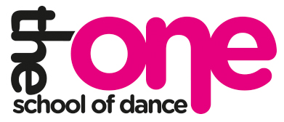

Class Fees (per week) Class Fees (per week)
Please read the welcome letter in regards to Please read the welcome letter in regards to
monthly payments. monthly payments.

Tinies Dance (30mins) £3 Tinies Dance (30mins) £3

All Boys (30mins) £3 All Boys (30mins) £3

Ballet, tap, Modern (1 hour) £6 Ballet, tap, Modern (1 hour) £6

Street Dance (30mins) £3 Street Dance (30mins) £3

1 x syllabus class (30mins) £3 1 x syllabus class (30mins) £3
(ballet or tap or modern) (ballet or tap or modern)

OFFER- All 3 syllabus classes £7.50 OFFER- All 3 syllabus classes £7.50

